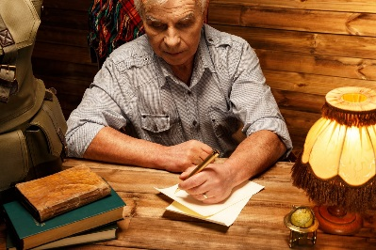
Short Story Writing Workshop
John Hope
www.johnhopewriting.com
Character Group Activity Character 1

Character’s Name

Physical Description

What he/she does / says / thinks (distinctive personality traits)

What he/she wants the most

Depth – Personal History (past/ongoing struggles)

Depth – Personal History (relationships)

Depth – Personal History (desires)

Depth – Personal History (vulnerability)

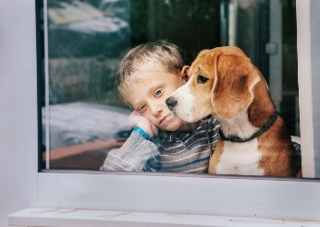
Short Story Writing Workshop
John Hope
www.johnhopewriting.com
Character Group Activity Character 2

Character’s Name

Physical Description

What he/she does / says / thinks (distinctive personality traits)

What he/she wants the most

Depth – Personal History (past/ongoing struggles)

Depth – Personal History (relationships)

Depth – Personal History (desires)

Depth – Personal History (vulnerability)

Short Story Writing Workshop
John Hope
www.johnhopewriting.com
Character Individual Activity

Character’s Name

Physical Description

What he/she does / says / thinks (distinctive personality traits)

What he/she wants the most

Depth – Personal History (past/ongoing struggles)

Depth – Personal History (relationships)

Depth – Personal History (desires)

Depth – Personal History (vulnerability)

Short Story Writing Workshop
John Hope
www.johnhopewriting.com
Conflict Activity 1 and 2

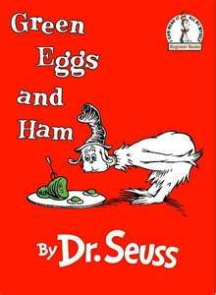
Green Eggs and Ham
Character-vs-Character

Character-vs-Self

Character-vs-Nature

Character-vs-Society

Comic
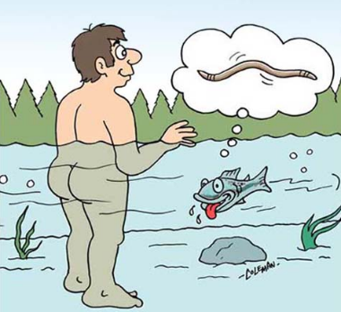
Character-vs-Character

Character-vs-Self

Character-vs-Nature

Character-vs-Society

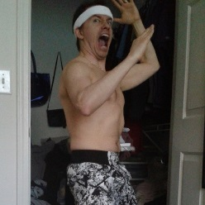
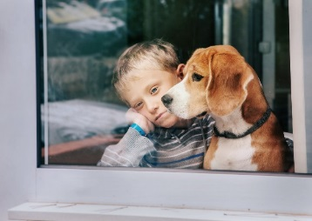
Short Story Writing Workshop
John Hope
www.johnhopewriting.com
Conflict Activity 3

Previous Characters
Character-vs-Character

Character-vs-Self

Character-vs-Nature

Character-vs-Society

Short Story Writing Workshop
John Hope
www.johnhopewriting.com
Description Activity 1

- Mr. Stevens, who was my former neighbor, won his lawsuit.

- There is a chat area on the Web called Study Hall that encourages students to talk with one another about college courses.

- He carries a briefcase made out of leather.

- He carries a briefcase made out of leather that is weather-beaten.

- The company is taking applications at this point in time.

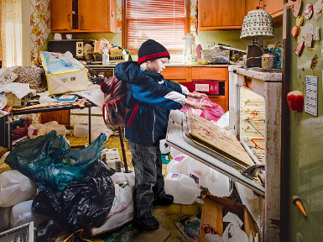
Short Story Writing Workshop
John Hope
www.johnhopewriting.com
Description Activity 2

Be Specific. Action Verbs. Use Senses.

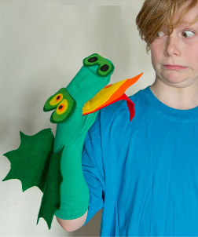
Short Story Writing Workshop
John Hope
www.johnhopewriting.com
Dialog Activity 2

Character’s Name

Physical Description

What he/she does / says / thinks (distinctive personality traits)

What he/she wants the most

Depth – Personal History (past/ongoing struggles)

Depth – Personal History (relationships)

Depth – Personal History (desires)

Depth – Personal History (vulnerability)

